Patrick Melia

Paul Reynolds

IT Sligo Induction app

Contents

Telerik backend. 2

Welcome screen 4

Drawer 4

Registration – Steps 5

Campus Map 6

Timetable 7

Code can be found here, on Patricks Github repo: <https://github.com/PMelia07/InductionApp>

# Telerik backend.

Screen shots.

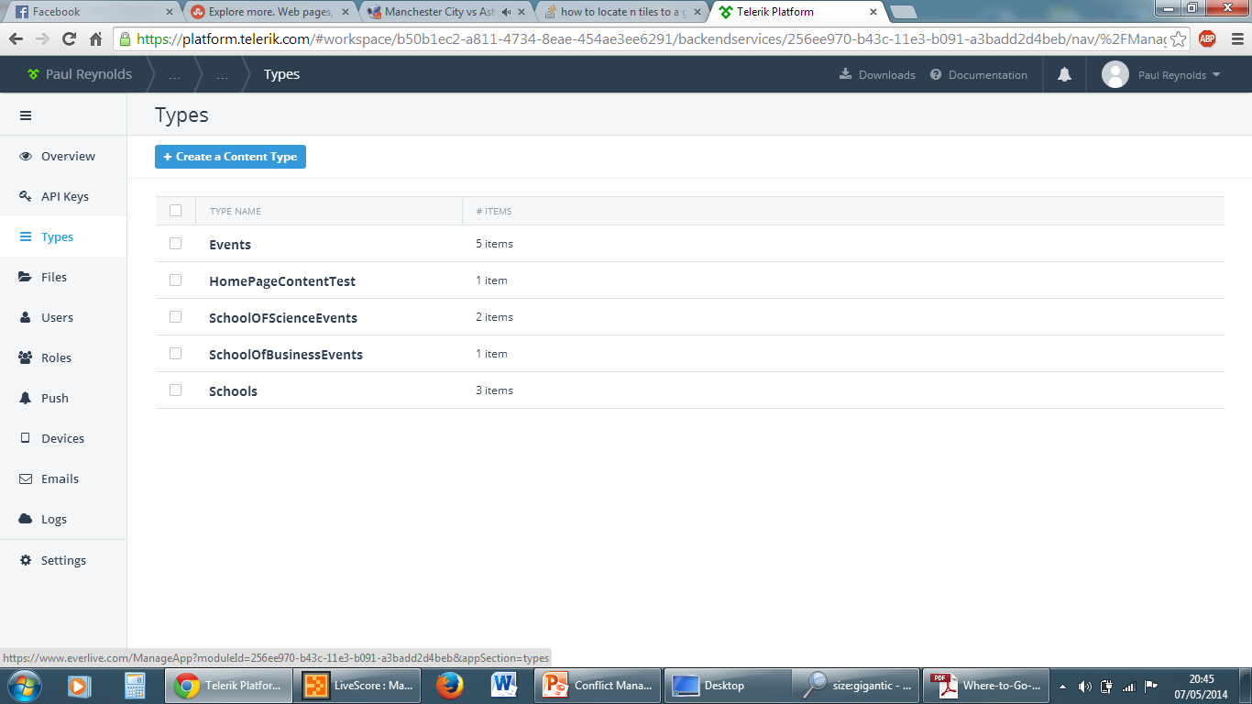

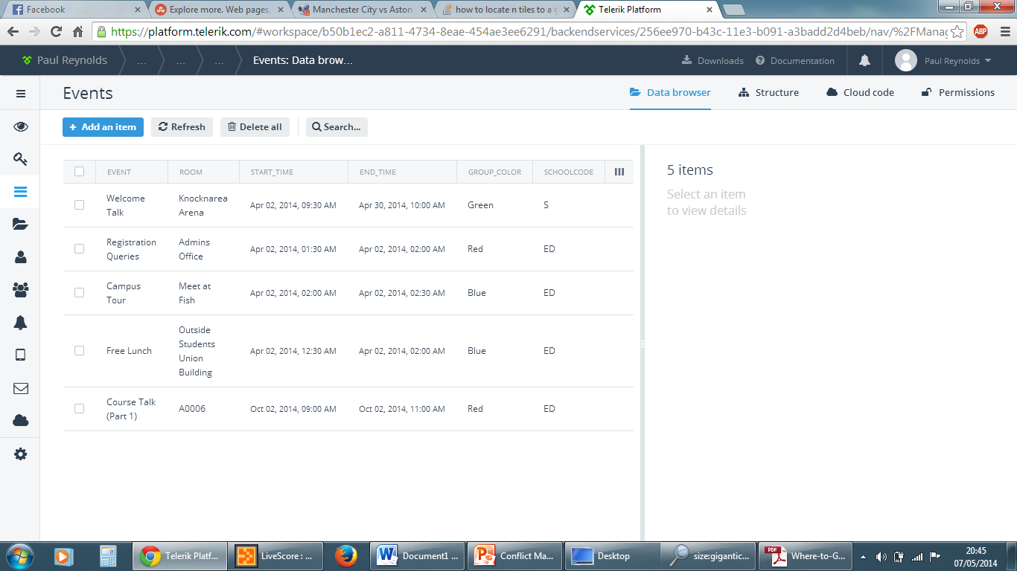

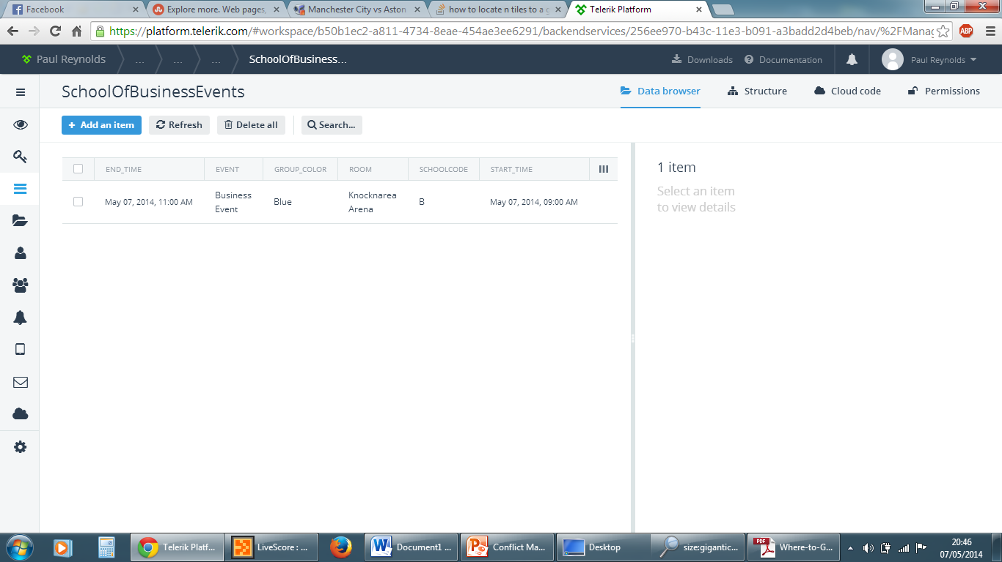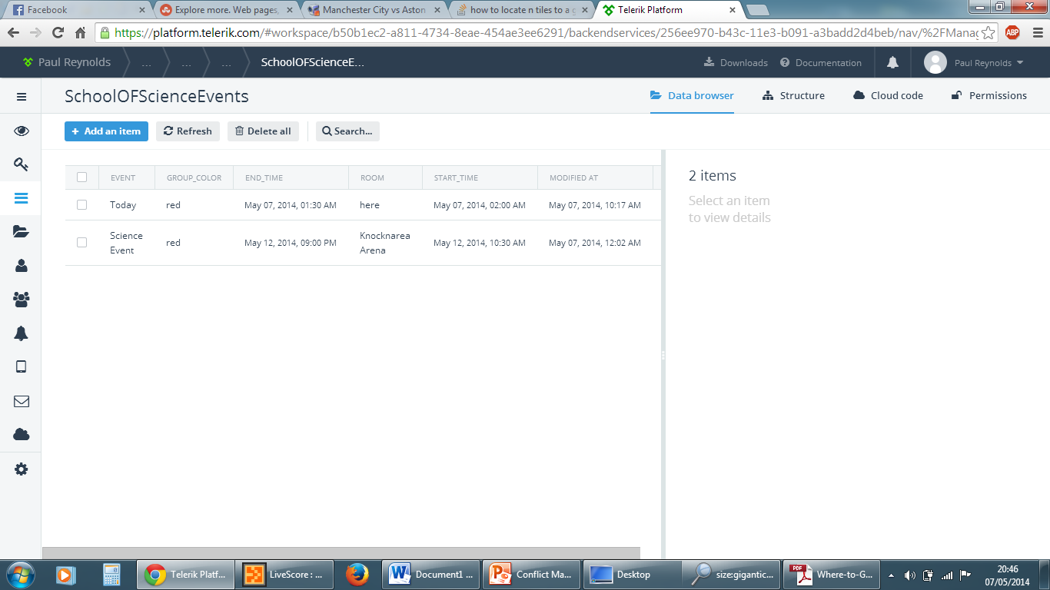

Welcome screen with picture of college and welcome text. 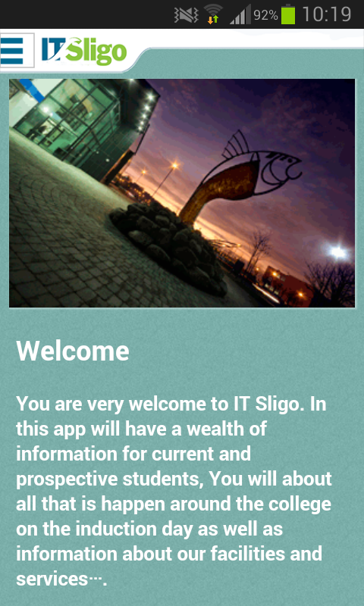

# Drawer

Here you can go to each page, call and email the college. You can also visit Facebook/Twitter.

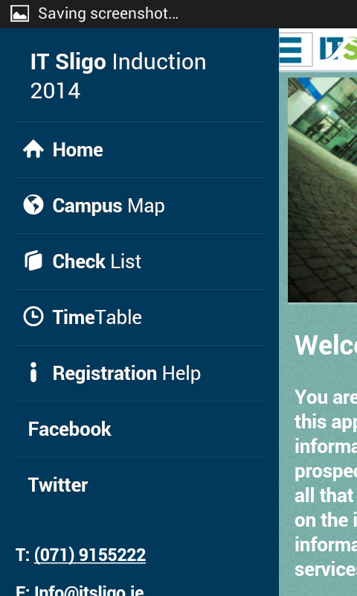

Registration – Steps

Here is the screens shots of the steps on how to register with ITSligo online.

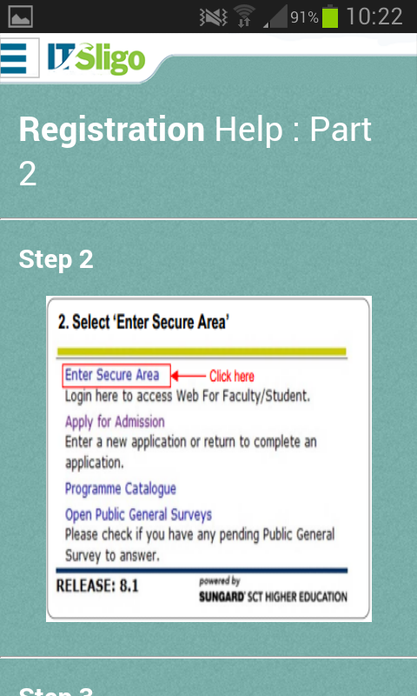 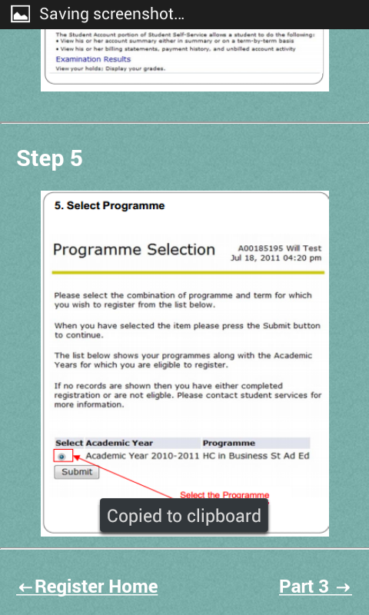 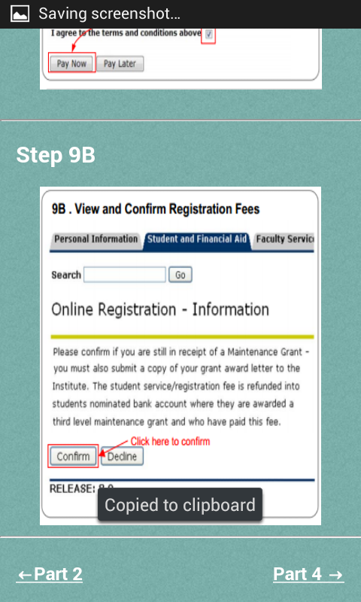

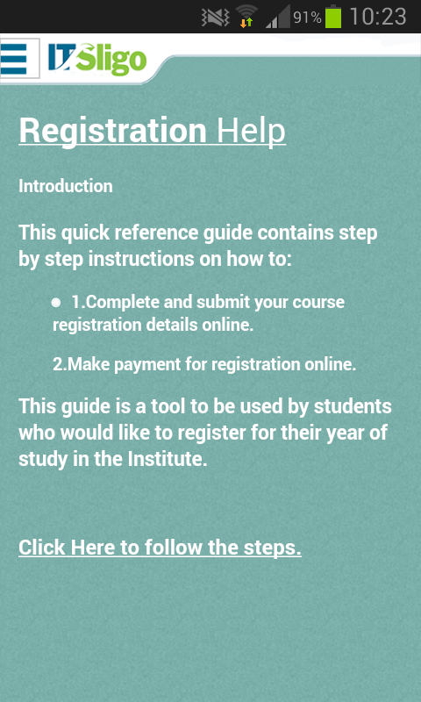

# Campus Map

Using Google map engine, you have all the different layers in the college. Your location is also picked up and showed on the map. You can find the map by clicking [here](https://mapsengine.google.com/map/edit?mid=zbflZXXuHETc.k4A8HIiHPoFk).

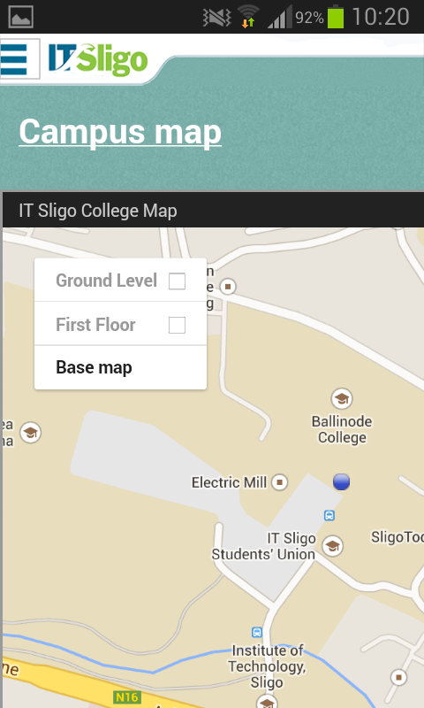

# Timetable

All content is pulled from Telerik Backend Services and displayed in the app using the Json/Javascript. Here is the screen shots from Telerik Backend.

